ASR 5845

* Will raise ASR on a change request. If container status “Truck in” not update , the system will prompt out message & block for loading.

Updated [2015.12.30]

Valid for ocean container - > condition where container# length is greater and equal to 11 char.

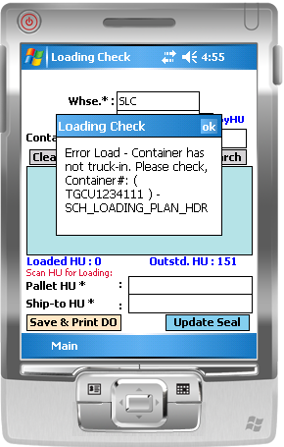

**From:** Chan, Pei-Fong   
**Sent:** Tuesday, 05 January, 2016 8:26 AM  
**To:** Yeo, Wei Khoon; Ming Fong, Chong; Cheang, Sin Loon; Choo, Fah Wang; Khin Koon, Lim; Li, Sha; Lai, Chu Tzek  
**Cc:** Tan, khang-hwee; David, Lim  
**Subject:** RE: Summarise of Meeting on 23Dec2015 - update

Hi Yeo and team,

Update for the below item #1: - ready for UAT. We will need to update the RF application.

* When there’s container ( container# length greater than 10), system will validate if truck-in status updated in system,
* If container has not truck-in yet,  system will prompt error message, and will not allow loading.

Also, please test the Update Seal # function:

Updated logic which system will validate update seal# windows time must be after 30mins of loading for Ocean shipment only, other local shipment will not have time validation.



Best Regards,

Pei Fong Chan (Ms)

IT Solutioning Department

Schenker Singapore (Pte) Ltd

17. Changi South Street 2, Singapore 486129

Phone (DID) +65 6549 1433, Fax +65 6545 6788

Mobile +65 9770 6919

________________________________________

[www.dbschenker.com](http://www.dbschenker.com)

Delivering Solution @ [www.deliveryingsolutions.dbschenker.com](http://www.deliveryingsolutions.dbschenker.com)

DB Ecoprogram @ dbecoprogram.dbschenker.com

[Please Consider The Impact To The Environment Before Printing This Email...]

**From:** Yeo, Wei Khoon   
**Sent:** Wednesday, 23 December, 2015 9:57 AM  
**To:** Ming Fong, Chong; Cheang, Sin Loon; Chan, Pei-Fong; Choo, Fah Wang; Khin Koon, Lim; Li, Sha; Lai, Chu Tzek  
**Cc:** Tan, khang-hwee; David, Lim  
**Subject:** Summarise of Meeting on 23Dec2015

Hi All,

Below is the discussion on Yesterday meeting issue.

1. Container “Truck in” not update “etracker” report keep showing of pending of container “Pending for Truck in” and container able proceed to load & truck out

* Will raise ASR on a change request. If container status “Truck in” not update , the system will prompt out message & block for loading.
* PeiFong , please provide the UAT date

1. Plan truck out in the “eTracker” report vs actual truck out is not accurate. There is a risk of container might fail to truck out still in our yard after the vessel depart from port.

* System setting for “Plan truck out date” in the report is 2 days before Vessel ETD date so that we still have 1 day to act on it before vessel departure. Base on the attach report trigger on the 21-Dec-2015 morning , the VGA containers supposed to truck out on 20-Dec-2015 which is Sunday and the container still not ventilate yet and the “Actual Plan” for the truck out is on 21-Dec-2015.This resulted the confusion trucking out especially during the weekends.
* Propose VW shipping to amend the “Plan truck out date” in the eTracker on “Container detail event” if there is any changes on the “Actual Plan truck out” or VW shipping will manually input the “Plan Truck out Date” in the eTracker header after communicating with the Transport Company on the truck out date. (Need Bee Yen advise on this, Ming Fong appreciate your help explain to Bee yen on the discussion for this point). Objective is to reflect the “Actual Truck out date” in the report to prevent any confusion.

1. Spoken to Choo to try use the system generate DO to serve as a Gate pass in SLC , this will reduce the manual writing the “Gate pass copy”. If there is no issue , it will kick off on the 28-Dec-2015.

Best Regards,

Yeo Wei Khoon (Mr)

Assistant Manager

Contract Logistics/SCM, Operations

Schenker Singapore (Pte) Ltd

5, Tuas View Lane, #02-01

Singapore 637291

DID: +65 6790 0247

Mobile: +65 9673 3951